Key Facts and Highlights:

- Design and Construction of 5.3 Miles of 500 kV Single Circuit Transmission Line
- Tubular Steel H-Frame Construction
- Bundled 1590 kCM Conductor
- Two 48-Fiber OPGW Cables
- Direct Buried and Drilled Pier Foundations
- Crossing of Four Existing 500 kV Lines
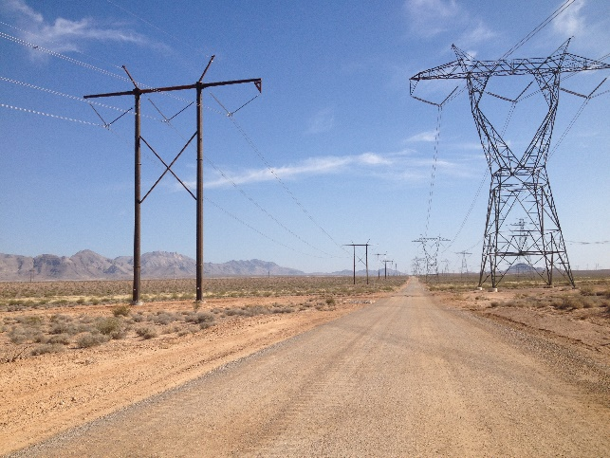
Located in Southern Nevada, the Moapa 500 kV Transmission Line serves as the interconnection of First Solar’s 250 MW Moapa Southern Paiute Solar facility. The transmission line consists of 5.3 miles of weathered tubular steel H-Frames, with three-pole structures used at dead-ends. The phase conductor is 1590 kCM 54/19 ACSR “Falcon” arranged in a vertical two-conductor bundle. Two 48-fiber OPGW cables provide redundant communication links between the solar facility and the interconnection substation. Tangent structures were direct embedded, and drilled pier foundations were installed to support angle and dead-end structures.
ECI was responsible for feasibility studies, routing, preliminary engineering, detailed design and survey. ECI’s subsidiary, EPC Services Co., was responsible for procurement, construction, construction management and project management. ECI’s engineering included conductor design, structure design, electrical design, insulator design, grounding design, foundation design, hardware design and PLS-CADD design. EHV studies completed included conductor studies, corona studies, EMF studies, lightning performance studies and grounding studies. Polymer insulators were utilized, and corona performance was verified with laboratory testing. Detailed design included the crossing of three existing 500 kV AC transmission lines and one existing 500 kV DC transmission line. Additional design, survey and grading plans were also required to ensure that structure earth pads were properly graded with respect to existing slide-slopes across the wider pole and drilled pier separations typical of EHV construction. Project criteria required incorporation of engineering and construction standards from two major utilities, including design reviews.
The transmission project was constructed ahead of schedule. A key technique applied by the project design team was conducting individual preparatory meetings for drilled pier construction, direct buried foundations, structure setting and conductor stringing. The objective of the preparatory meetings was to ensure that all stakeholders understood the construction specifications, construction methods, schedule, installation constraints and inspection requirements. Additionally, contractor submittals were verified and approved. The preparatory meetings were critical in maintaining the project schedule as well as ensuring effective construction quality control.

